WASH Projects Underway for 4 Schools in Chiltiupan and Jicalapa, La Libertad, El Salvador
The Rotary Club of Cheyenne and Rotary Club of San Salvador

The World Community Service (WCS) Committee of the Rotary Club of Cheyenne is pleased to announce the El Salvador WASH project GG2231398 for 4 schools is underway. As the Primary International Partner, the WCS Committee worked to raise $50,000 for the project to improve bathroom and kitchen facilities, enhance hygiene practices and provide sanitation education in the schools, Centro Directivo Escolar la Perla, Centro Directivo Escolar Canton las Flores, Complejo Educativo Santo Domingo, and Centro Directivo Escolar La Pedrera, located in Chiltiupan and Jicalapa, municipalities in La Libertad, a coastal region of El Salvador.
The objective of this project is to improve school attendance, reduce illness, and advance the level of learning within the schools and community on issues related to water, sanitation, and hygiene while also providing WASH training and education for the community to make the project successful and sustainable. The extent of the work to be completed in the schools varies and is outlined in the 2021 School Assessment: 'Visit to Schools of the WASH Project'. School selections were based on access to water, number of students served, level of need, and commitment from the school directors, mayor, and community.
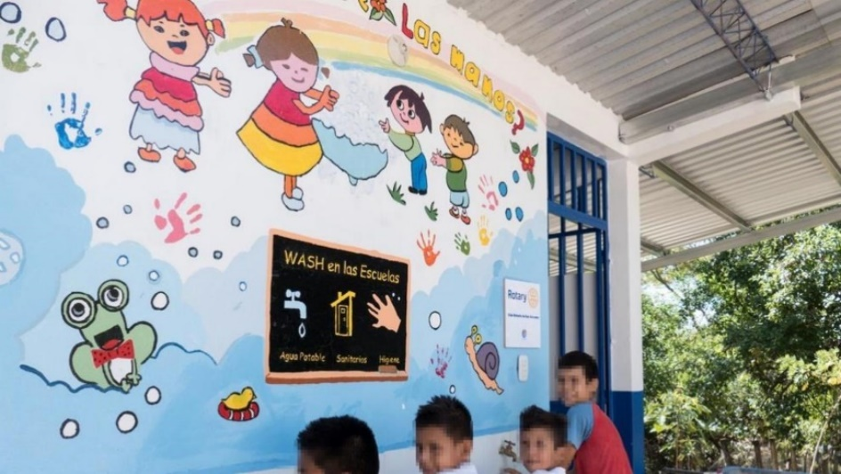
This project is an extension of Global Grant GG1988461 a pilot program which was successfully completed in 2019-2020 for 3 other schools in El Salvador. For a video recap and to see the impact of this project, you can follow the link: 2019-2020 WASH Project Video . Surveys from the pilot project show over 5,900 benefited from the project including 961 students, 32 teachers, and over 5,900 indirect beneficiaries. A similar reach and number of beneficiaries is anticipated with this project as well.
In addition, the COVID-19 pandemic has had negative socioeconomic impacts in these communities. Access to wash stations and implementing good hand washing and hygiene practices are critical in the recovery of the outbreak and to mitigate long-term impacts on the community livelihood and wellbeing. This project will encourage good hygiene practices by improving the daily practices of the people and elevating the standards for water services and sanitation - critical for containing the virus, lowering its impacts and socioeconomical aftermath, and keeping the students in school.
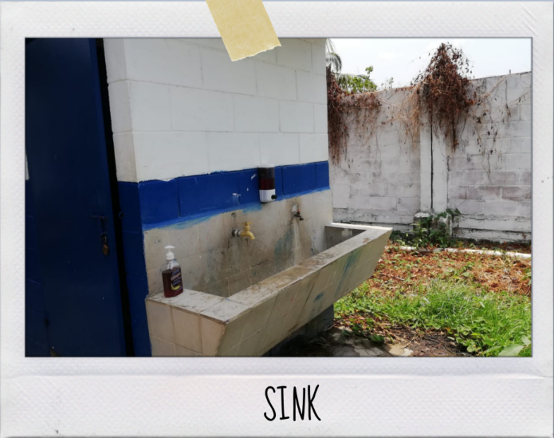
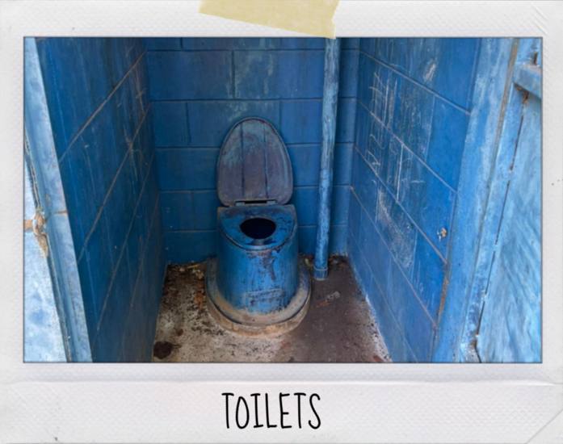
The WCS Committee members would like to extend our deepest appreciation to the following clubs and individuals for their support of this project: Rotary Club of Cheyenne membership and Board, Rotary Club of Ft. Collins, John Trone Family Foundation, Cheyenne Rotary After Hours, Laurie-Sunrise Beach Club (Lake of the Ozarks, MO), and San Salvador Rotary Club (Primary Host Partner), as well as the supporting Districts 5440 and 4240 for their matching funds.

Yours in Service,

Jera Likely-Schlotthauer
Board Member, Public Relations
World Community Service Committee Member
Rotary Club of Cheyenne
jeraschlotthauer@gmail.com

